**BORIS Encoding Process**

**Contents:**

1. **File Storage and Setup**
2. **BORIS Setup**
3. **BORIS Creating a Project**
4. **BROIS Creating an Ethogram**
5. **BORIS Creating an Observation**
6. **BORIS Coding Behaviours**
7. **File Storage and Setup**

The files are stored on the university’s secure server at *\\storage.hcs-wlg.otago.ac.nz\uow-ph-kidsonline\Dunedin Campus*.

Access to this is granted by the University of Otago’s IT team. You can connect to the server through a VPN  (Cisco AnyConnect Secure Mobility Client). Once installed, follow these instructions to connect to the VPN,

1. Open File explorer, and in the address line, type \\storage.hcs-wlg.otago.ac.nz
2. Find the Kids Online folder
3. Right-click; click on 'map network drive...' (about 2/3rds of the way down the list).
4. In 'Drive' - Type Z: and click ‘FINISH’.
5. Open File Explorer, and the Kids Online server will appear in the drop-down menu within the “This PC” header.

Each school has a BORIS project file containing the recordings and the BORIS project file.

The file structure in the storage drive is laid out in the following way. All video files are kept in the 2021 – KIDS ONLINE STUDY DATA folder.

1. Create a folder for the specified school with the convention 2021 School Participants BORIS
2. Create a folder for each participant from the school.

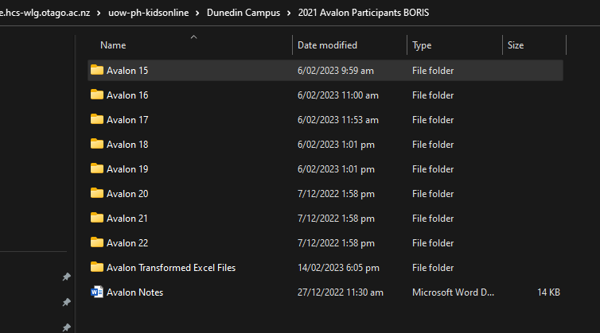

1. Create one folder for the BORIS Excel Exports and one for the BORIS project files.

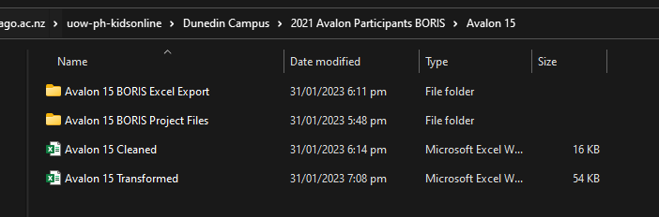

1. Copy the participant's video files from the secure server to the folder. You are now ready to set up the BORIS project file.

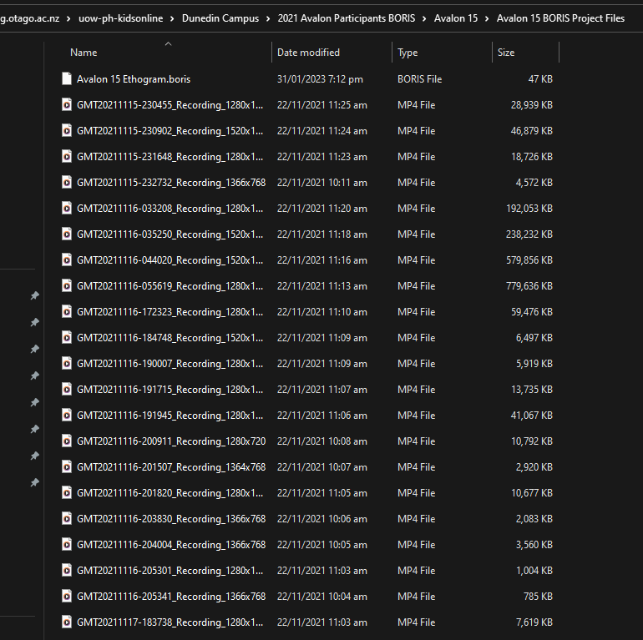

1. **BORIS Setup**
2. To download BORIS go to <https://www.boris.unito.it/>. Once downloaded, open up BORIS and GO TO file, then new project.

1. **BORIS Creating a Project**
2. Enter your project name – This will be the name of the participant followed by “observations”, e.g. Newlands 1 Observations
3. Graphical user interface, text, application, email

   Description automatically generatedSelect the “Time format” – please select hh:mm:ss.mss.
4. **BROIS Creating an Ethogram**
5. To create an ethogram, either create it when setting up the project or go to file and then edit project.

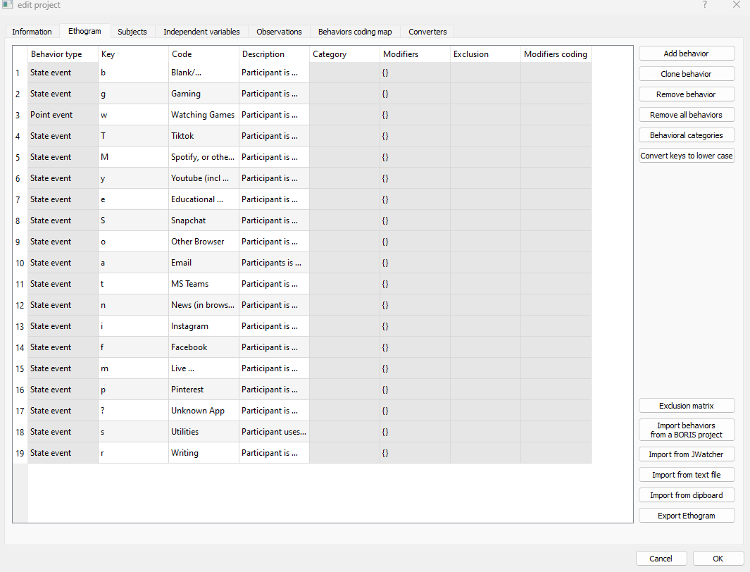

1. Add behaviours as desired by selecting add behaviour from the right-hand side menu. It is a good idea to export the ethogram to easily import it into the following projects (options for this are located in the bottom lefthand side menu).
2. The key corresponds to the key pressed when that behaviour occurs so choose something that makes sense to you.
3. **BORIS Creating an Observation**
4. Go to observation new observation

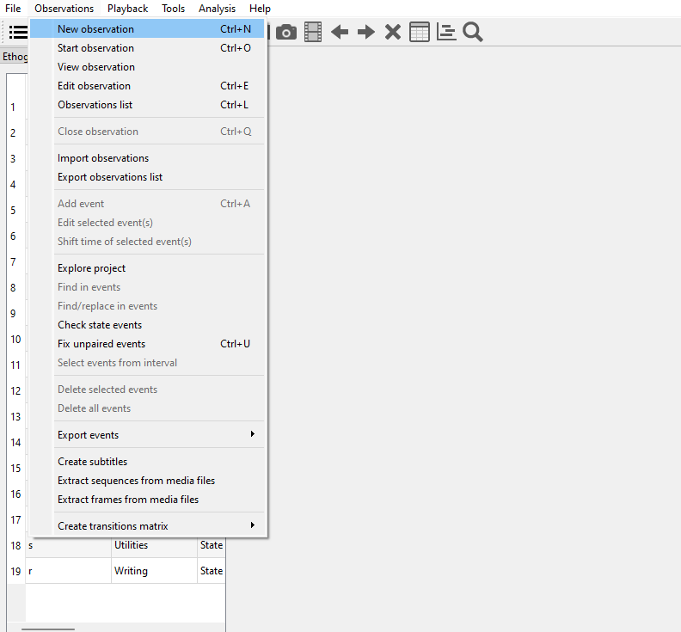

1. Observation id – copy the file name of the intended media file for this observation (1 media file per observation).
2. Date and time – change this to the date and time when the media file was recorded. (NB: use 24-hour time – e.g. 01:35 PM is 13:35:00)
3. Description – enter:
   1. Participant ID-device type on which the media file was recorded. (e.g. Newlands1-phone).
   2. Day of the week, date, and time (12-hour time format) of recording. (e.g. Thu 17/06/21 0130 PM).
4. Click on “add media without path” – select the correct media file, which should be present in the same folder as the participant project template file (this is what you have prepped in Step 1).
5. **BORIS Coding Behaviours**
6. To begin coding behaviours, go to observations and start observation. Click on the observation and select start.
7. To make it easier, you can select tools and then a coding pad to create a separate window.
8. Select the play button from the top menu and begin coding.

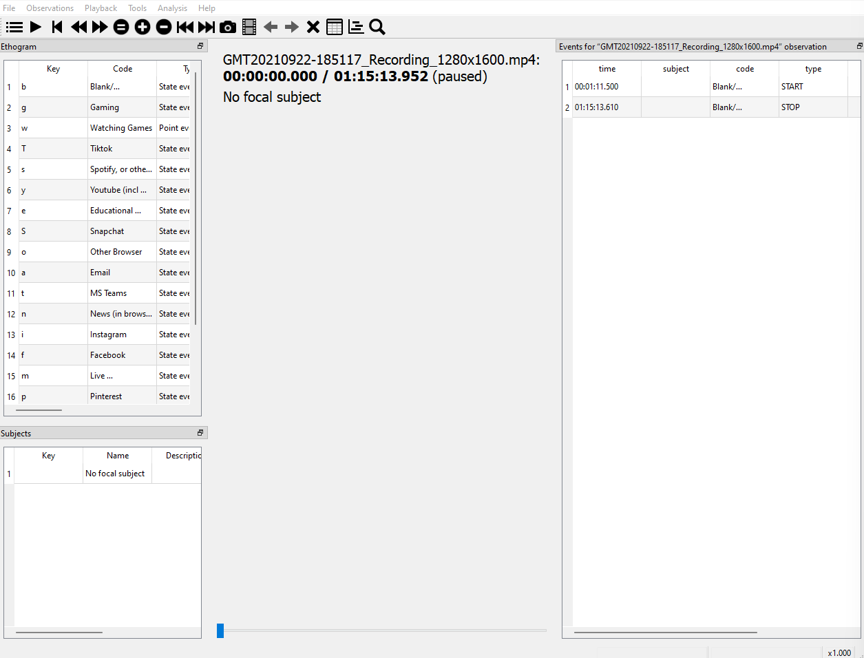

1. The menu on the top allows you to speed up, slow down, jump forward and backwards and pause. Use these functions appropriately, as they can make coding more manageable and allow you to make up for any mistakes. You can also jump back to any event or delete an event by clicking on the event from the righ-hand side.